Construction Environment Management Plan

HESSAY

Representative |  | Job Title | Signature | Date
Prepared by: | Lee Onslow | Group SHE Manager | Lee Onslow
Approved by: |  | Project Manager
Issued to: |  | Site Manager
Works Completed |  | Client
Name:

Change record

Minor amendments may be carried out by Ethical Power Ltd Site Manager named in this document, this must be recorded below and re-briefed to all engineers/operatives on site.

Major changes must be discussed and approved with the author of this document, prior to the works being undertaken. The CDM Plan must be re-briefed & re-signed by all parties’ concern.

Any significant changes to the Plan resulting from design changes will only be done after consultation with the Principal Designer.

Version | Revised By | Job Title | Reason for Change | Date

Contents

1.0.Project Information 5
1.1. Site location 5
1.2. Site details 6
1.3.Development Proposals 6
1.4.Planning notice: 6
1.5.Environmental aims for the project 7
1.6.Site Induction & Training 7
1.7.Incident Reporting & Investigation 8
2.0.Environmental Considerations 8
2.1.Project Specific Environmental Targets 9
2.2.Project Specific Environmental risks 9
2.3.Water Conservation Measures 10
2.4.Energy and Carbon Emission Conservation Measures 10
2.5.Temporary Storage Compound areas 10
2.6.Nuisance Management 11
2.7.Materials Management 12
2.8.Oil, Fuel and Liquid Chemical Storage 12
2.9.Soil and Sediment Management 13
2.10.Pollution Prevention Measures 13
2.11.Waste Management 13
2.12.Ecology Clerk of Works (ECoW) 14
3.0.Flooding & Surface Water Drainage 14
3.1.Background 14
3.2.FRA 27th March 2023. 15
3.3.Subsoil infiltration. 15
3.4.Site Waterbodies. 16
3.5.FRA initial assessment. 17
3.6.FRA second Addendum: 18
3.7.Revised Surface Water Drainage Scheme: 18
3.8.FRA Drainage Summary - Conclusion. 18
3.9.Surface Water Pollution Control. 20
3.10.Adoption and Maintenance of SuDS 20
3.11.Flood Evacuation Management Plan. 21
3.12.Water Quality 21
3.13.Substation SuDS 22
3.14.Transformers SuDS 22
4.0.Construction Details and Management 22
4.1.Control of Dust 22
4.2.Noise and vibration 23
4.2a. Noise Survey Planning Approved. 23
4.3.Refuelling site Machinery 23
4.4.UXO Assessment 24
4.5.Aviation Emergency Provision 24
4.6.Windsock Provision 24
4.7.Aviation Maintenance Schedule 25
4.8.Glint & Glare Survey - Overall Conclusions: 25
4.9.ARCHAEOLOGICAL GEOPHYSICAL SURVEY 25
4.10.Trial Trench Evaluation 26
5.0.Ecology & Biodiversity 27
5.1.Mitigation 27
5.2.Tree Protection 27
5.3.Tree Solutions Survey: 28
5.4.CONCLUSIONS: 29
5.5.Hedgerows. 29
5.6.Tree and Scrub Planting. 30
5.7.Ditches. 30
5.8.Pond Enhancement. 30
6.0.Species Habitat – Hibernacula - Construction Phase. 31
6.1.Operational Phase 31
6.2.Hibernacula 31
6.3.Invasive Non-Native Species 31
6.4.In the event Invasive Non-Native Species is detected 31
6.5.Nesting Birds 31
6.6.Bats 32
6.7.Dormice 32
6.8.Badger. 33
6.9.Barn Owl. 33
7.0.BNG and Biodiversity Improvements 34
7.1.Objectives 34
7.2.Monitoring and Management Overview 34
7.3.Conclusions 36
Appendices 37
Appendix 1. Planning Notice 23/00626/FULM: 37
Appendix 2. Decision Notice: 37
Appendix 3. Conditions Approval 8a, 10, 13, 15: 37
Appendix 4. NMA Proposed site layout: 37
Appendix 5. Revised LEMP and Ecological BNG: 37
Appendix 6. Flood Risk Assessment: 37
Appendix 7. Flood Risk Assessment Addendum: 37
Appendix 8. Substation Relocation: 37
Appendix 9. Approved Substation Elevations: 37
Appendix 10. Approved Internal Track Design: 37
Appendix 11. Site Access Route: 38
Appendix 12. Trial Geophysical Survey: 38
Appendix 13. Trial Trenching and Earth Works: 38
Appendix 14. AIA: 38
Appendix 15. Noise Impact Assessment: 38
Appendix 16. UXO Assessment: 38
Appendix 17. Aviation Prevision: 38
Appendix 18. Glint and Glare Study: 38
Appendix 19. TX / STS Type Test: 38
Appendix 20. Site Waste Management Plan: 39

1.0.Project Information

Site location
South of Low Moor Lane, Hessay, Yorkshire, YO23 3RR. The land is currently used for agricultural purposes with no previous planning history. It is divided into 8 fields enclosed by native hedgerow. Hessay development field complex is accessed from the south via Tinker Lane, leading from Height Lands Lane, B1224 and A1237 wider road network.
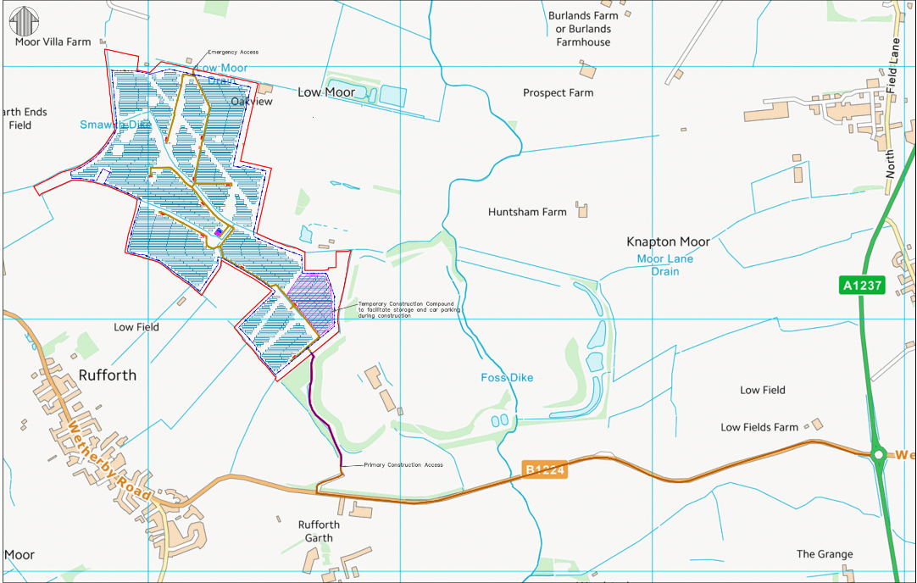
Figure 1 Site Location showing construction access route.
Site access via Tinker Lane - What3Words///: active.gaps.picturing

Site details
Hessay site comprises 61.3 hectares of agricultural land located in a rural setting 550m southeast of the village of Hessay, Yorkshire, centred on National Grid Reference (NGR) SE 530 528.

1.3.Development Proposals
The Site is predominantly comprised of arable farming, with the northern parcels being utilised as grazing for cattle. The Proposed Development comprises the installation and operation of a ground mounted solar farm over an area of approximately 61.3ha. The associated infrastructure is to include access roads, cabling, invertor platforms, control room; combined Customer and DNO Substation; storage containers; Transformer and Switch Gear Housing, security fencing & CCTV; and a temporary construction compound, also improved vehicle access. Along with new species-rich grassland, native tree and shrub planting, plus new wildflower areas for biodiversity enhancement. Hedgerow Infill Planting: creation of Herptile Hibernacula (2 no.) Bird Boxes (6 no.) Bat Boxes (6 no.)

1.4.Planning notice:
York City Planning approval notices ref 23/00626/FULM, NMA 25/01219/NONMAT and Approval of Details AOD/24/00209. The development was approved by The Planning Inspectorate on 23rd September 2024 in accordance with the terms of application reference 23/00626/FULM submitted to York City planning inspectorate 6th April 2023 and Non Material Amendment (NMA) dated 19th June 2025. Discharge of conditions 8a, 10, 13, 15, and 18, have been granted under notice ref. 25/01219/NONMAT.

1.5.Environmental aims for the project
The aim is to carry out all works on the Solar Park to the highest environmental and ecological standards, in a safe manner and mitigating damage to the wider Environment.

The site will be inspected at regular points throughout the project by Ethical Power Ltd. Head of SHEQ. These inspections will be non-scheduled health, safety and environmental spot check inspections. As a minimum there will be inspections conducted at the start of construction, mid-construction and in the closing stages of the construction phase, pre-commissioning. Alongside this, there will be monthly site visits conducted by the site’s environment and sustainability advisor.

Detailed inspection reports will be produced and shared with all concerned parties. Ethical Power will maintain a non-conformance register to ensure any and all issues are followed up and dealt with in a timely manner.

Ethical Powers aim is to complete this project, with no environmental incidents throughout the duration.

1.6.Site Induction & Training
Personnel will not be permitted on site unless they have received sufficient induction training. This induction will include site specific information about the project, including health and safety issues/concerns related to the site, site control measures, as well as any site-specific environmental issues/considerations.

All Ethical Power Ltd engineers and operatives hold in date qualifications and certification. A copy of all certificates will be available for inspection upon request.

The site manager will deliver the site induction and records will be kept. Visitors must report to the site manager who will brief them on the relevant site-specific risks and the necessary control procedures. Site visitors will be expected to hold relevant job specific qualifications and certifications and have read the site rules for visitors. Any on-site training given will be in the form of briefings, induction training or toolbox talks.

The Site manager will maintain a record of all site-based training (tool-box-talks) on the EP_095_Toolbox Talk Attendance Register which is located in the Site Managers Site Folder. Tool-box-talks will be delivered on a minimum weekly basis.

The Site Notice Board will display:
- Ethical Power Ltd. H&S And Environment Policies.
- F10.
- Insurance.
- Emergency response plan.
- H&S at work act.
- Emergency resuscitation.
- Nominated first aiders poster.
- Relevant information poster.
- Pollution prevention and response procedure.
- Environmental Memos, Alerts and Toolbox Talks.

1.7.Incident Reporting & Investigation
It is the responsibility of all engineers, employees, visitors, contractor’s etc. to ensure that all accidents, incidents, dangerous occurrences, close calls, near misses, dangerous working practices or environmental considerations are reported in accordance with the Ethical Power Ltd reporting matrix.

All dangerous occurrences and potential hazards shall be reported immediately to the SHEQ team so that necessary actions may be implemented to reduce an identified risk.

Following any reportable occurrence, the SHEQ team shall review the scope of works, method statement, risk assessment and safe systems of work to ascertain where improvements can be made to the working process.

Should the incident be of a serious nature, the head of SHEQ shall attend the site at the nearest opportunity, to conduct an onsite incident investigation and produce an incident investigation report if required.

The site manager is responsible for ensuring that any incidents involving sub-contractors, are to be reported through the EPL incident reporting procedures as a subcontractor incident. Contractors and subcontractors are required to report all sub-standard work incidents involving their workers, including environmental practices and ecological requirements, to the site manager, providing EP with an Incident Investigation Report.

All reports, interviews and witness statements and other related evidence, shall be recorded in writing and held on EPL servers along with the Incident Investigation Report.

The client will be informed of all incidents/accidents that occur on site as soon as possible via phone call/email. This will be followed up with an Incident Report when necessary.

2.0.Environmental Considerations
Extreme care will be taken to ensure that the immediate and wider environment is affected as little as possible by the construction activities.

Below is a project checklist to consider; permissions and documents that may be required, and control measures and management strategies to be adopted, including those responsible for actioning them and ensuring they are in place:

Site Environmental Register | Site Manager
Environmental permits | Site PM / Manager
Method Statements/ Risk Assessments | Site Manager
COSHH Assessments | Site Manager
Pollution prevention and response operating procedure | Project Manager
Head of SHEQ site visits | Head of SHEQ
Section 60/80 Notices | Project Manager
Section 61/81 Consents | Project Manager
Site Waste Management plan | Site Manager
Trade Effluent Consents | Project Manager
Water discharge permit/procedure | Project Manager
Other Consents (Archaeological, Hedge Removal, Tree Removal etc.) | Project Manager
ECOW | TBC

2.1.Project Specific Environmental Targets
Environmental targets for the project are as follows:
- No pollution incidents during construction works.
- Environmental Toolbox Talks are to be carried out weekly and be recorded on the Toolbox Talk Record.
- All environmental risks are to be included in site induction.
- The EPL SHEQ team is to be notified straight away if any suspected Protected Species or Archaeological remains are encountered.
- Where deemed applicable ecology reports are to be completed and provided by the client.
- Existing protected species onsite are to be protected through the use of exclusion zones and strict RAMS.

2.2.Project Specific Environmental risks
Project specific Environmental risks are as follows:
- Waste management
- Material usage & procurement
- Diesel/gas oil & electricity usage
- Use of water
- Site drainage
- Tree protection
- Tree root protection
- Hedgerow protection
- Site transport
- Nuisance Management – Noise, dust & vibration
- Spread of INNS
- Harm / disturbance of wildlife
- Watercourse pollution

2.3.Water Conservation Measures
- Toilet facilities to be fitted with push taps and systemisers.
- Hose pipes are to be turned off when not in use.
- Rainwater to be collected and utilised where possible, for dampening dust etc.

2.4.Energy and Carbon Emission Conservation Measures
Energy used on site will be minimal as there is no main power to the site and temporary welfare units will run off internal hybrid solar/diesel generators which will be turned off outside of site operating hours.
The following energy conservation measures will however be adopted where appropriate:
- Temporary accommodation heaters will be turned off between 18:00hrs - 07:00hrs, except for the drying room and office / printer area, where the heaters will be set to a lower temperature out of hours, if required. Similarly external lighting will be energy efficient LED lights on either photocell or timer clocks.
- All delivery, construction and visitors vehicles are not to be left running or idling when not in use.
- Safe and careful driving is encouraged onsite through the use of speed limits (5mph); this is monitored using remote tracking devices fitted in vehicles.
- Vehicle movements for site deliveries and cart away purposes are planned to consider route efficiency.
- Disposal and recycling facilities are chosen taking their locality to the site into account.
- Powered equipment is to be kept well maintained and in good efficient working order to ensure efficiency.
- External solar energy battery bank charging cupboards will be installed to provide charging facilities for 24v batteries.

2.5.Temporary Storage Compound areas
During the construction phase of the project there will be a requirement for a Temporary Storage Compound Area. The compound will be to the East of site, accessed via an improved bellmouth leading off Tinker Lane directly into field 8. The compound will be of a permeable construction utilising crushed road stone, with the access track and bellmouth being of a similar construction. The compound will be defined and secured by temporary security fencing and CCTV security system to deter criminal activity.

The temporary compound area will accommodate temporary portacabin-type buildings providing site offices, canteen and welfare facilities. In addition to the temporary buildings on this area, there will be areas for material offloading and storage and parking spaces for construction staff. The compound will be used to store deliveries to site that are not taken directly to their location of use, and to transfer loads from HGV delivery lorries to smaller vehicles such as “telehandlers” and other site plant to facilitate delivery to site.

The compound will be constructed on 2000 sqm of crushed road stone. At the end of the construction period, all buildings, welfare facilities, temporary fencing, equipment and stoned area will be removed, with the area being restored to level grass land. For a short period of construction, following the temporary compound removal, an off-site reception area will be established to manage construction traffic, final deliveries of materials and the transportation of equipment and plant from site.

2.6.Nuisance Management
To ensure any nuisance to neighbours are reduced as far as reasonably practicable the following controls and considerations will be taken:
- In line with the approved LEMP, Site working hours will be 8am – 7pm Monday to Friday and 8am – 1pm on Saturdays. No working on Sundays or Bank Holidays.
- Delivery vehicles will be limited to Monday – Friday, 10am – 4pm. No deliveries are to take place at weekends or on Bank Holidays.
- Where appropriate a letter will be delivered to nearby residents and business before the start of the project. This will detail a brief outline of the project and introduce the project team including any relevant contact details. Where relevant, there after a newsletter may be issued with any updates as necessary.
- Where applicable, the Local Authority Environmental Health Officer will be kept informed of all upcoming activities that may impact on the local residents.
- A complaints register will be maintained. The Project Manager will take immediate action on receiving a complaint.
- All vehicles and machinery will be switched off when not in use and serviced/calibrated as required.
- To minimise environmental, noise and pollution risks, methods have been chosen which will minimise the noise produced by the works activities. As necessary, we will also undertake perimeter noise monitoring prior to the contract commencing to establish the normal levels for the site.
- Dust will be controlled throughout the project as detailed in section 4.1.Control of Dust.
- Transfer of vibration will be controlled throughout the works by using controlled working methods to reduce large ground impacts and large machinery and machinery that may produce ground vibration will be positioned on site to vibration to dissipate effectively were reasonably practicable.
- No burning is permitted on site.
- No high frequency audible reversing alarms will be used on site.
- Wheel washing stations and mud-mats will be positioned at site entrances to minimise sediment tracking onto the public highways, when required.
- Regular road sweeping will take place, the frequency of which will be determined by site and weather conditions. This may include ad-hoc road sweeping following particularly wet weather.

2.7.Materials Management
In terms of management of materials on site this will pertain mostly to waste materials and how they are processed and dealt with.

The following measures will be in place:
- All hazardous materials will be kept within a locked storage area, and access to these materials will be restricted to authorised persons. All of these materials will have corresponding COSSH assessments stored onsite.
- Materials are to be stored correctly in designated bins or stockpiles for the appropriate waste stream to prevent cross contamination.
- Efficient use of materials will be encouraged in terms of appropriate ordering (sizes etc.) and planning delivery, storage and handling to minimise the risk of damage (and therefore waste).
- Where waste materials are concerned all debris generated by the construction process will be segregated into appropriate waste streams to be processed as most appropriate in line with the waste management hierarchy as set out by Environmental Protection Act 1990; and the Environmental Protection (Duty of Care) Regulations 1991 in order of preference.

2.8.Oil, Fuel and Liquid Chemical Storage
- The storage of all oil/fuel containers with a capacity of 200ltrs or more will comply with the requirements of the Control of Pollution (Oil Storage) regulations. Generally, this means that:
- Oil drums are to be stored on proprietary secondary containment systems that will contain 110% of the contents of the largest container, or 25% of the total, whichever is greater. These are to be protected to minimise the ingress of rainwater and secured against unauthorised discharge.
- All bulk storage tanks are to be integrally bunded proprietary tanks. The tanks are to be located within the compound area of the site, away from general traffic movements and surface water drains, and secured against unauthorised discharge.
- Only authorised and competent personnel will be issued with a key to the bulk storage tanks for refuelling machinery. When refuelling, the operator must remain in attendance at all times.
- The Site Manager is to be notified of all spillages, however minor.
- There will be no chemical or fuel discharge to the surrounding area from plant /equipment / vehicles or structures throughout the duration of the construction. Where possibilities arise for contamination, pollution prevention equipment will be deployed before any activity takes place.
- Spill kits will be available on site and site personnel informed of their locations during induction.
- Oils and other chemicals, in containers with a capacity of less than 200ltrs, will be stored within a locked store, either on impervious floor or drip trays. Only authorised personnel will be issued with a key to this store.

The location of any Subcontractors' oil storage areas and procedures must be agreed with Site Management prior to any deliveries. No storage will be permitted within 10m of the stream or surface water drains.

2.9.Soil and Sediment Management
    - Silt fencing will be installed along watercourses, dykes, drainage ditches, and around ponds, also including pre-determined locations/boundaries on site to prevent the mobilisation of silt into watercourses or site drainage.
    - Topsoil stockpiles left in-situ for 30+ days will be stabilised with vegetative cover or rolled erosion control product during winter months. Disturbed areas will be re-vegetated where construction is not expected for 30-days with a minimum 50mm of topsoil and hydro-seeding or other stabilisation/erosion control. Stockpiles to comply with Defra Construction Code of Practice for the Sustainable Use of Soils on Construction Sites
    - Wheel-washing facilities will be established along with regular sweeping to manage dust and silt on internal tracks. Wheel washing to be kept to a bunded impermeable area, at least 10m from any surface waterbody. Wastewater directed to a storage tank and removed by tanker or adequately treated (i.e. Silt buster) prior to discharge.

2.10.Pollution Prevention Measures
    - Oil and liquid Chemicals are to be stored and handled as described above in Section 2.8.
    - Drip trays are to be used when refuelling machinery and all leaks are to be reported to site management and SHEQ team and cleaned up immediately.
    - All plant must be equipped with an individual spill kit.
    - No wastewater is to be pumped into any controlled waters or to any foul or surface water drains.
    - Concrete mixing will be off site where possible. If not possible, limited to a designated area, bunded over an impermeable surface. Waste-water removed by tanker or treated appropriately.

2.11.Waste Management
Every step possible will be taken to minimise waste through the implementation of the waste hierarchy as outlined within Section 12 of The Waste (England and Wales) Regulations 2011.
So far as reasonably practicable, we shall:
    - Prevent waste through sustainable procurement strategies and resourcing recyclable materials.
    - Re-use waste material in its current state if safe and legal to do so.
    - Recycle waste as much as practicable.
    - Dispose of waste only once all other options have been exhausted.
    - Only licensed waste carriers shall be used to transport waste and thorough duty of care checks will be carried out prior to any movements taking place.
    - During times of high winds and overnight, all skips onsite will be covered to prevent spread of pollution/litter.
    - Each site has a Site Waste Management plan outlining appropriate waste classification and streams, displayed in the site office. Copies of the plan will also be supplied to all contractors working on site, (link in appendices).

2.12.Ecology Clerk of Works (ECoW)
- The role will be required to perform a number of duties on site. To aid ecological protection during construction.
- Review construction method statement (CMS) produced by the Principal Contractor.
- Preparation and delivery of ‘tool-box talks’ to Principal Contractors Site Manager and construction staff to ensure that the ecological sensitivities of the site are fully conveyed to all staff.
- Maintenance of an active register of all open/closed issues which arise during the construction phase. This will include photographic record and regular progress/inspection log.
- In the event of an environmental emergency situation, the ECoW will have the power to stop works immediately in the area affected upon receiving notification of such an incident.
- Any such incidents will be catalogued in the active risk register and a report prepared for the Client in a suitable format that would enable swift delivery to City of York Council and/or EA if appropriate.

3.0.Flooding & Surface Water Drainage

3.1.Background
The Environment Agency Flood Map for Planning indicates the site to be predominantly located in flood zone 1, with the north-eastern corner of the site located in flood zone 2. The north-western boundary of the site is indicated to abut flood zones 3 and 2.

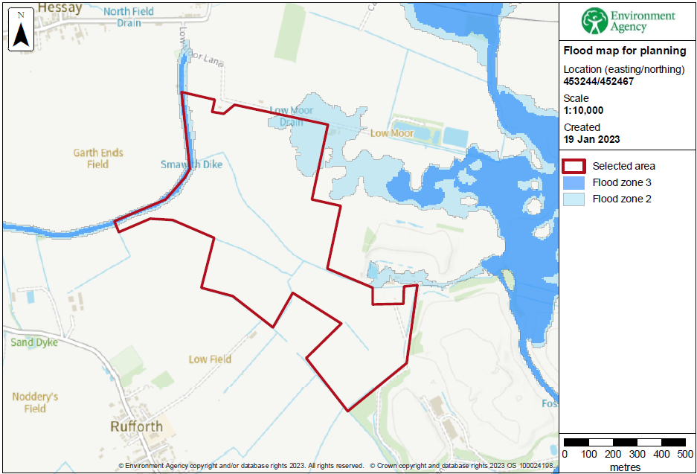
Figure 2 Environment Agency Flood zone map – 3 & 2.

3.2.FRA 27th March 2023.
The site is assessed to be at a low to medium risk of flooding from small watercourses and surface water.
Although during a low frequency/high severity (1 in 1,000 AEP) event, there is the potential for widespread flooding within the northern half of the site between Smawith Dyke and Low Moor Lane Dyke, and within the southeastern portion of the site, with flood depths generally between 150 to 300mm. Flood extents are shown to significantly reduce during less extreme events.
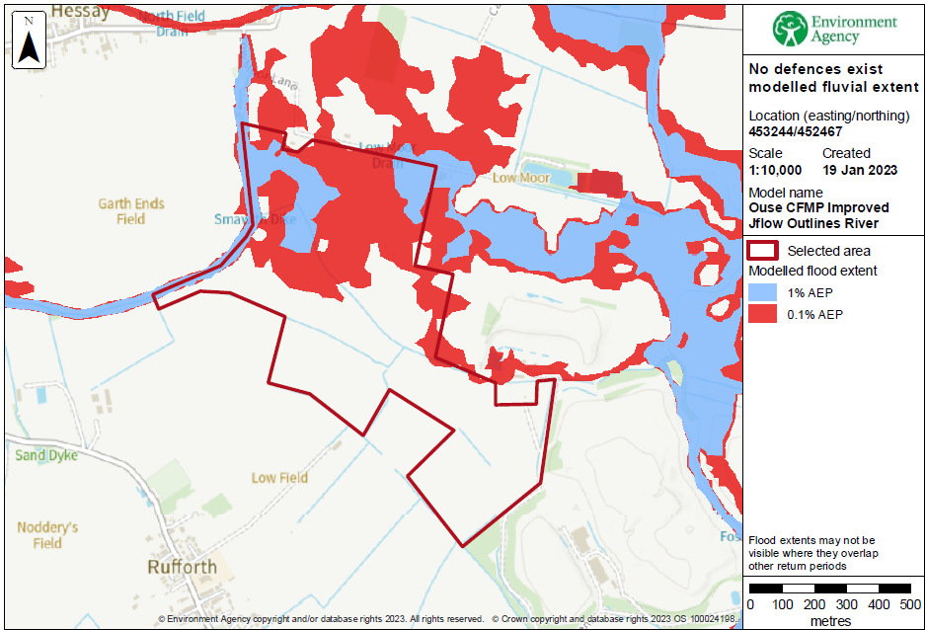
Figure 3 Environment Agency Fluvial 1 in 1,000 AEP Flooding Extent.

3.3.Subsoil infiltration.
As detailed in the FRA assessment submitted under 23/00626/FULM. Hessay site is underlain by soils with impeded drainage, overlying clay. The FRA desktop study, together with the density of the network of agricultural drainage ditches, provides strong evidence that the disposal of surface water via infiltration is unlikely to be feasible. It is therefore proposed to direct runoff from the developed site to the on-site drainage ditches. For the purposes of this assessment, the site has been subdivided into four drainage areas based on the location of surface waterbodies.
Figure 4 Subdivided Drainage areas.
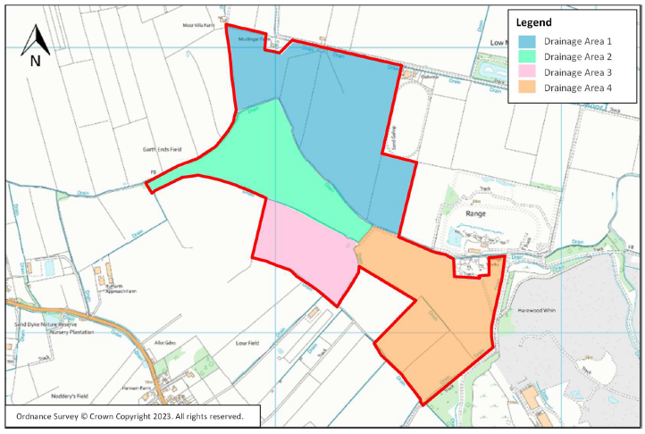

3.4.Site Waterbodies.
Hessay site has a network of drainage ditches on and within the vicinity of the site (as shown in Fig. 4 below), including Smawith Dyke, Rufforth North Dyke (B), Oak Nursery Dyke, Tinker Lane Dyke and Low Moor Lane Dyke. Most of the on-site drains fall under the jurisdiction of the Ainsty (2008) Internal Drainage Board (IDB). The watercourses ultimately outfall to the River Ouse approximately 3.7km north of the site. Laybourne Lakes is located approximately 280m east of the north-eastern corner of the site and a pond is located approximately 40m to the north of the south-eastern portion of the site.

Surface Waterbodies in the site vicinity.

Figure 5 Surface waterbodies map.
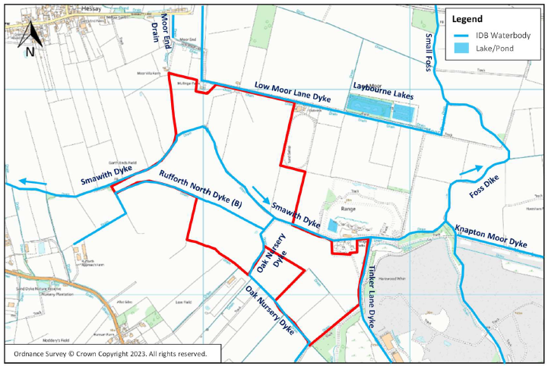

3.5.FRA initial assessment.
An initial FRA drainage scheme assessment was submitted and approved under 23/00626/FULM in March 2023. The initial FRA assessed that the site is not at risk of flooding from groundwater, reservoirs, canals or other water impounding structures.

The Environment Agency stated in its consultation letter dated 21 April 2023 that it did not object to the proposals provided that the development was built in accordance with the submitted FRA report.

Ainsty (2008) Internal Drainage Board (a member of the York Consortium of Drainage Boards) responded to the proposals by way of a consultation response letter dated 13 April 2023. In its letter the Board made a number of observations contrary to the initial FRA and EA statement. Which culminated in the submission of additional information in an FRA Drainage Addendum (version 1.0; Issued on 24 October 2023; Doc. ref: 5767/TN/Final/v1.0/2023-10-24), inclusive of revised Landscaping Plan, and revised Site Plan, agreed by “the Board” dated 30 and 23 November 2023 respectively.

Revised Drawings of the Inverter Station (elevations) and of the internal access roads (cross-sections showing build-up and confirming that that access roads would be “flush” with adjacent ground were also submitted in October 2023. Ainsty (2008) IDB confirmed in October 2023 that these drawings were acceptable from a Board perspective. Combined with planning approval NAM 25/01219/NONMAT, relocating the combined DNO / Client substation and Spares Container.

3.6.FRA second Addendum:
Flood Risk and Drainage Assessment – 2nd Addendum presents the additional information requested by the Lead Local Flood Authority, namely a revised surface water drainage scheme with associated levels (to m AOD).

3.7.Revised Surface Water Drainage Scheme:
The surface water drainage scheme presented with the Flood Risk and Drainage Addendum (v1.0) has been revised as summarised below:

- Combined Customer & DNO Substation compound constructed of permeable Type 3 aggregate to a depth of 300mm, laid level with adjacent ground.
- The sub-base for the compound area would be 529sqm, and the sub-base and would provide up to 47.6cu/m of attenuation storage. The pass forward outflow would be restricted to a maximum rate of 1.0 l/s by a flow control device (e.g. Hydro-Brake® Optimum flow outlet device, model MD-SHE-0050-1000-0750-1000) or equivalent.
- The headwall for the outfall to the watercourse would be designed in accordance with Ainsty (2008) Internal Drainage Board requirements at detailed design stage and full details will be provided for prior written consent.
- The internal access tracks will be flush’ with adjacent ground, i.e. not raised. As such, there will be no change to ground levels, and no additional information is therefore provided on level.
- The design calculations and revised drainage scheme layout are provided in appendices to this document respectively.
- For reference, the following drawings, all approved by the Ainsty (2008) Internal Drainage Board are presented as appendices to this document:
- Revised Site Layout.
- Revised Landscaping Plan.
- Inverter Station Elevations.
- Internal Access Track Cross-Section and Build-up.

3.8.FRA Drainage Summary - Conclusion.
As detailed in the initial FRA assessment, the site is underlain by soils with impeded drainage, overlying clay, restricting surface water infiltration. The Flood Risk Drainage Assessment – 2nd Addendum (see document 23_00626_FULM-FLOOD_RISK_ASSESSMENT_ADDENDUM-2656576), proposes a scheme of direct runoff from the developed site to the on-site drainage ditches be incorporated in the site design, details as follows, (document link provided in appendices).

- Internal access Tracks to be designed as attenuation storage for the site.
- Internal access Tracks designed with a minimum construction depth of 300mm of Type 3 aggregate, (incorporating Terram 1000 Geotextile Fabric and Geogrid Mesh or similar).
- Access Tracks finished levels to be flush finish with adjacent ground level.
- Combined Client/Substation compound area to be designed as a site attenuation storage.
- Compound area for the combined Customer / DNO Substation and Spares Container: Constructed of permeable Type 3 aggregate to a minimum depth of 300mm, laid level with adjacent ground. The sub-base for the compound area will be 529sqm, the sub-base should provide 47.6cu/m of attenuation storage.
- Surface Water and Attenuation Storage runoff piping, to be designed with a minimum diameter of 50mm.
- Connection pipes between Attenuation Storage and site Drainage Ditch Network to be designed incorporating Flow Control Devise (e.g. Hydro Brakes), (head=0.75m Flow=1.0L/s Control diameter = 50mm, CL = 14.10, IL = 13.10(out), as described in the Flood Risk and Drainage Assessment – 2nd Addendum.
- Headwalls for the outfall to the watercourse would be designed in accordance with Ainsty (2008) IDB requirements at detailed design stage and full details will be provided for prior written consent.
- Existing drainage ditches/dykes to be retained.
- Substations, Storage Containers, site buildings or infrastructure located within or near the 1 in 1,000 AEP surface water flood extent to be set at a minimum of 300 mm above AOD or adjacent ground levels, whichever is the greater.
- No substations, inverter/transformer stations or storage containers located within 9m of the top of watercourse banks maintained by the IDB, or within 3m of ordinary watercourse banks not maintained by the IDB.
- Array panelled areas of the site to comprise managed grassland.
- Concentrated surface water runoff to be mitigated by utilising a well-maintained vegetation cover, (appropriate seed mix) which can be managed by grazing.
- Ground under the solar array drip line to be seeded with a suitable grass mix to prevent rilling soil erosion.
- New access crossings (culverts) on existing drainage ditches to be designed to maintain existing conveyance capacity. Inline with Ainsty (2008) IDB guidance.
- Surface water runoff from the access tracks and other areas of hardstanding to be restricted to flow rates to suit a flow control diameter of 50mm as to avoid the risk of blockages, with storage provided within the Type 3 access track material.

Ainsty 2008 Internal Drainage Board.
Contacts.
Clerk and Engineer to the Board W Symons: Tel 01904 720785
Planning and Consents C Gill: Tel 01904 720785

Figure 6. Typical Flow Control Hydro Brakes detail.
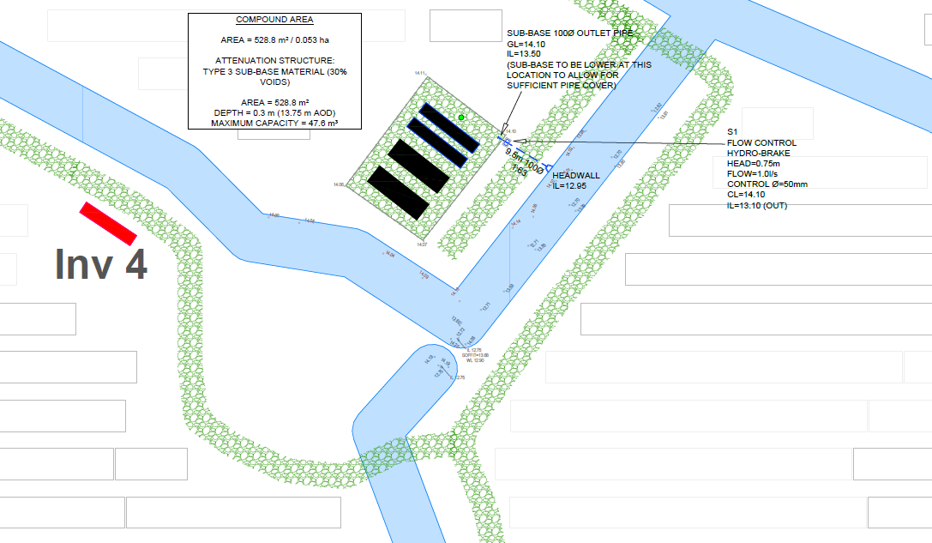

3.9.Surface Water Pollution Control.
Table 26.2 of the CIRIA SuDS Manual (2015) identifies general access roads as having a low pollution hazard level and indicates that the pollution hazard indices associated with general access roads for total suspended solids, hydrocarbons and metals are 0.50, 0.40 and 0.40 respectively.
It is recommended that the access tracks are constructed with a Type 3 crushed road stone to allow surface water runoff to be stored and treated within the pavement structure.
Table 26.3 of the CIRIA SuDS Manual indicates that the SuDS mitigation indices for permeable paving for total suspended solids, hydrocarbons and metals are 0.70, 0.60 and 0.70 respectively.
The CIRIA SuDS manual identifies commercial roofs (inverter/transformer stations, sub-stations and storage containers) as having a low pollution hazard level, as such minimal treatment measures would be required to treat the quality of the water.

3.10.Adoption and Maintenance of SuDS
The surface water drainage system will be maintained by the site operator or their appointed management company. An indicative maintenance schedule is presented in table 1.
Table 1: Maintenance Requirements
Schedule | Required action | Frequency
Type 3 Permeable Access Tracks
Occasional maintenance | Stabilise and mow contributing and adjacent areas | As required
 | Removal of weeds or management using glyphosphate applied directly into the weeds by an  applicator rather than spraying | As required – once per year on less frequently  used pavements
Remedial actions | Remediate any landscaping which, through vegetation maintenance or soil slip, has been raised  to within 50mm of the level of the paving | As required
Remedial work to any depressions and rutting
considered detrimental to the structural performance or a hazard to users

Schedule | Required action | Frequency
 | Rehabilitation of surface and substructure | Every 10 to 15 years or as required
Monitoring | Initial inspection | Monthly for three months  after installation
 | Inspect for evidence of poor operation and/or weed growth- if required, take remedial action | Three-monthly, 48h after  large storms in first six months
 | Inspect silt accumulation rates and establish appropriate removal frequencies | Annually
Flow Control Unit
Routine maintenance | Remove litter and debris and inspect for sediment  accumulation | Six Monthly
 | Remove sediment from sump | As necessary – Indicated by system inspections
Remedial actions | Replace malfunctioning parts or structures | As required
Monitoring | Inspect for evidence of poor operation | Six Monthly
 | Inspect flow control unit and establish appropriate  replacement frequencies | Six Monthly
 | Inspect sediment accumulation rates and establish appropriate removal frequencies | Monthly during first year of operation, then every six months

3.11.Flood Evacuation Management Plan.
A Flood Evacuation Management Plan (FEMP) will be prepared for onsite staff/visitors. The Site is not in an area which receives Environment Agency issued flood warnings, therefore the FEMP will rely on onsite observations of watercourses and Met Office weather warnings.

3.12.Water Quality
The following mitigation measures will be implemented to protect the water environment:
- All site works will be undertaken with suitable temporary drainage measures in place and in accordance with the Environment Agency’s ‘Pollution prevention for businesses’ notes in order to minimise the potential risk of increased sediment reaching nearby surface waters.
- Silt fencing will be installed to protect the watercourses present on site.
- An internal permitting system will be utilised to regulate and monitor dewatering activities, pH and oil test strips will be used to monitor the water quality before, during and upon completion of dewatering activities. Regular monitoring will enable adjustments to practices to prevent pollution of the water environment.
- Following removal of the tanks and/or bunded areas the exposed formation will be samples and tested to demonstrate no adverse impact from the storage.
- Spill response kits will be available on site in the event that there is spillage or leakage from fuel and chemical storage and also from potential leaks from plant.
- Should any spillage or leakage occur the Site Manager will be informed immediately, and the spillage/leakage will be cleaned up using the spill response kits.

3.13.Substation SuDS
Surface water from the buildings/hardstanding areas will shed onto surrounding stoned areas (i.e. essentially a large filter drain), which will be constructed using a minimum of 300mm thick layer of Type 3 permeable aggregate, over Terram 1000 Geotextile Fabric and Geogrid Mesh or similar, which will capture any oil and sediment.

3.14.Transformers SuDS
Surface water from the buildings/hardstanding areas will shed onto surrounding filter drains Filter drains will be constructed using single Type 3 permeable aggregate, over Terram 1000 Geotextile Fabric and Geogrid Mesh or similar, which will capture any oil and sediment.

4.0.Construction Details and Management
All construction works will be carried out in line with best practice guidance. An Environmental Clerk of Works (ECoW) will be appointed. To monitor sensitive ecological and ornithological receptors immediately prior to and during the works and to monitor compliance with schedule of mitigation appointed.

4.1.Control of Dust
The operations activities are likely to generate levels of Dust during periods of dry weather. Methods and equipment will be selected to reduce production of airborne dust.
- In addition to this, dust suppression will be provided where necessary in the form of water sprayed over the immediate work area. This will be delivered by way of water truck, misting systems (Dust Boss), or similar to ensure materials are constantly wet down and to catch any airborne particulates before they can become a nuisance.
- Where on site traffic routes might cause issues with dust this would be controlled by maintaining site cleanliness with traffic routes kept swept clean or by wetting down traffic routes and wheel washing facilities to be used to prevent airborne dust.
- Materials carted away from site will be covered and / or wet down before leaving the site to further prevent any airborne dust. Where necessary vehicles leaving site might be washed to prevent dust or dirt being spread outside of the site boundary.
- Whilst dust control techniques are key to reducing exposure, they may not always prove completely effective and so operatives working on site may still be subject to exposure, all be it greatly reduced. For this reason, when necessary, respiratory protective equipment (FFP3) is provided to employees and face fit tested.

4.2.Noise and vibration
The operations activities are likely to generate levels of both noise and vibration onsite and to the surrounding local area above normal levels prior to works. Noise generating works will be limited between 8am and 7pm from Monday to Friday and 8am to 1pm on
Saturdays. No Saturday afternoon, Sunday, evening, or night-time working is proposed. When necessary, both noise and vibration assessments will be carried out prior to commencement onsite to establish baseline levels. Should the requirement arise, further assessments will be carried out throughout the project to determine occupational and environmental noise and vibration levels. Where levels are found to exceed Exposure Action values, all measures available will be made to reduce impact to the local community and environment, employees will be also be made aware of risks and provided suitable protection.

4.2a. Noise Survey Planning Approved.
An independent Noise Impact Assessment was carried out by Bureau Veritas instructed by Atmos Consulting Ltd. The NIA Conclusion is noise mitigation in the form of sound barriers will be required around 11 inverter locations due to sound levels being calculated to be 12dB above background. Therefore 9 inverters would require a 3m high acoustic barrier and 2 inverters would require a full enclosure Inv10 and Inv11.
NOTE: the NIA assumes Hessay Solar Farm design contains 11 x HEM/K & PCSM/K Gen 3 Inverters, sound capacity at 1m distance of 80.8 dB(A).
NOTE: Hessay Solar Farm, 2026 updated design, does not include HEM/K & PCSM/K Gen 3 Inverters. Hessay Solar Farm design moving forward will incorporate Sungrow SG350HX inverters. The Sungrow inverter has a lower noise level compared to the HEM/K inverter. The Sungrow unit also differs in its deployment location within the solar array. Sungrow SG350HX inverters sit below the solar panels, mounted on the solar mounting frame. Meaning the solar panels automatically act as a sound barrier.
Due to the differences in sound levels and deployment location. Once Sungrow inverters are installed and energised, a second NIA will be commissioned to evaluate the requirement for sound barriers to be installed.

4.3.Refuelling site Machinery
Refuelling will either be carried out off-site otherwise a designated, bunded refuelling site will be established on an impermeable surface at least 10 distant from any watercourse or drain. Drip trays with 110% storage capacity will be used beneath diesel generators and other relevant plant. Spill kits will be kept on site at all times and site staff will be trained in their use. Machinery will be routinely checked to ensure they are in good working order and spill kits should be on site in case of a spill.

4.4.UXO Assessment
1st Line Defence has assessed that there is an overall Low Risk from German and anti-aircraft unexploded ordnance at the site of proposed works. There is also a variable risk from Allied UXO across the site, with the majority of the site being Low Risk, but the south-eastern section of the site being elevated to Low-Medium Risk, (link in Appendices).
Figure 7 UXO Risk Map
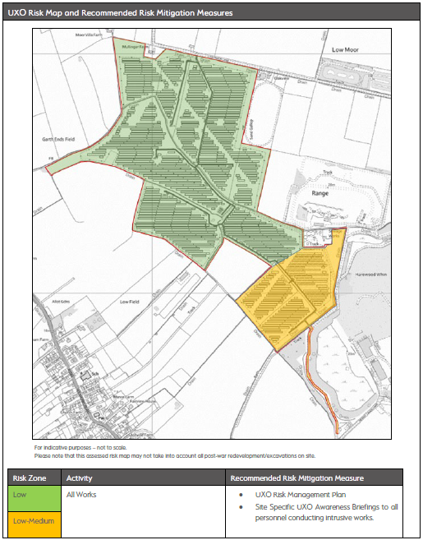

4.5.Aviation Emergency Provision
Emergency landing provision comprised of a 25-metre wide x 293 metre long, landing strip to the northeastern extent of the approved application site. The landing strip is within the boundary of the operational development and as a result not accessible by members of the public. Fencing along the eastern edge of the panelled area will retain the landing strip free of any grazing livestock.
Centre line marking is required to ensure pilots can align to the centre of the landing strip. This is proposed to consist of concrete paving slabs arranged to create a 0.6 x 3 metre ‘line’ painted white and positioned on the centre line of the landing strip at 75 metre intervals, the top of each slab will be set to the surrounding ground level to ensure no artificially elevated areas are introduced.
Ground cover across the landing area will comprise of a low wildflower / grass mix which will be maintained in line the detail in the LEMP.

4.6.Windsock Provision
Windsocks are proposed at 3 key locations across the operational site shown in the Site GA. Windsocks proposed are to be mounted on 6 metre poles, appendices contain details of the windsock type to be used on site.

4.7.Aviation Maintenance Schedule
Maintenance Schedule and Egress Procedure to ensure the continued ability of the emergency landing strip to serve aircraft in trouble, there will be a need to maintain the emergency landing strip and the windsocks. The landing strip will be retained free from any permanent obstructions. The centre line markings will be trimmed monthly between April - October to ensure continued visibility, as required through the growing season, and refreshed to white where any evidence of discolouration or loss of paint marking is found. Windsocks will be checked visually on a quarterly basis and will, bi-annually, be dropped for detailed checks. Windsock condition will be checked to ensure viability and performance is maintained and replacements installed as required when degradation could cause failure of the windsock to inflate. Mechanical assessment of the pivot joints will also be undertaken to ensure free movement, lubrication will be applied as required and replacements made where necessary.

4.8.Glint & Glare Survey - Overall Conclusions:
No significant impacts are predicted upon road safety, residential amenity, or aviation activity at Gilrudding Grange Airfield. Solar reflections with a maximum intensity of ‘potential for temporary after-image’ (‘yellow’ glare) are predicted towards both assessed 1-mile approach paths for runways 23 (Rufforth East Airfield) and 17 (Rufforth West Airfield), as well as sections of the visual circuits for both Airfields. There are mitigating factors that reduce the overall impact; in particular, the low percentage of time glare will occur throughout the year and that instances of ‘yellow’ glare will occur outside the usual operating hours of the airfield. Overall, it is judged that the potential effects can be operationally accommodated (Section 5.2.4) and mitigation is not recommended, (link in Appendices).

4.9.ARCHAEOLOGICAL GEOPHYSICAL SURVEY
The aim of the geophysical survey was to identify any potential archaeological anomalies that would enhance the current understanding of the archaeological resource within the proposed survey area.
In assessing the results of the geophysical survey against the specific aims. The survey has succeeded in locating, recording and characterising surviving sub-surface
remains within the Site, though more remains may be present that are not suitable for
detection through magnetometry. No anomalies of a definite, or probable, archaeological origin have been identified.
The geophysical survey identified several modern utilities cross the site and are likely to be associated with the sewerage works which lies on the eastern limits of the Site. Additional linear trends have been noted across the Site which are typical of field drains with many forming distinctive herringbone patterns. Image showing the onsite sewerage pipe locations can be seen below in figure 8 Geophysical Images, and link to full document in appendices.

Figure 8 Geophysical image.
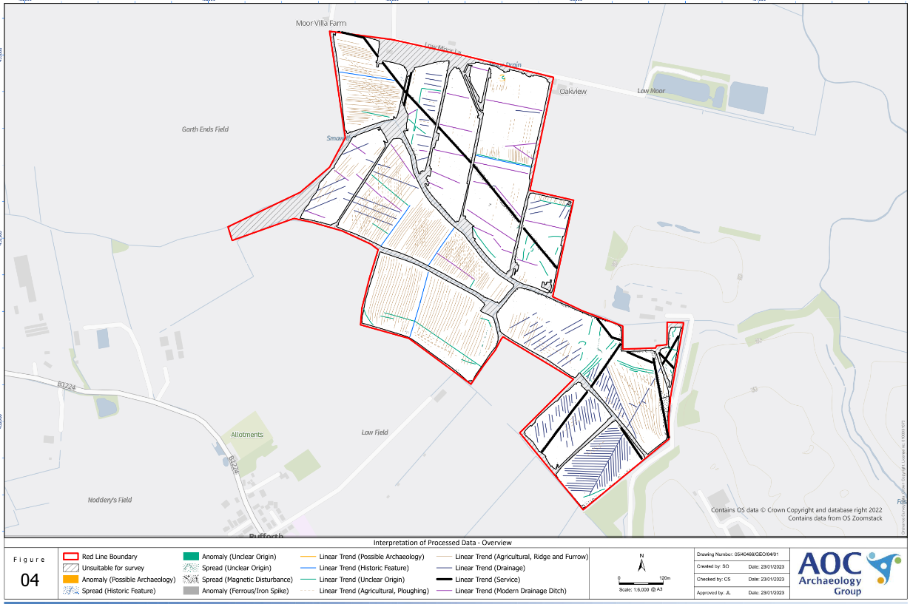

Note: The solar array design has taken the locations of on site utilities into account. However great care is required when excavating and piling across the site. HSE CDM2015 recognised safe digging practices need to be followed. CAT-scan and generator surveys must be carried out and a Permission to Dig form must be issued by the Site Manager before any works start.

4.10.Trial Trench Evaluation
Rocket Environmental Services Ltd was commissioned by the Client, Hessay Solar Limited, to undertake a trial trench evaluation to support a planning application for the development of a solar farm on land near Hessay, York. The proposed development is outlined in planning application no. 23/00626/FULM. A programme of post-determination archaeological evaluation (trial trenching 3%) and recording of ridge and furrow (field 7) is required on this site. The archaeological scheme comprises 3-5 stages of work. Each stage shall be completed and agreed by the Local Planning Authority (LPA) before it can be approved.
It is recommended that no further archaeological works are required as part of the proposed development 23/00626/FULM. The final decision on the appropriateness of this recommendation lies with the City of York Council. Rocket Environmental Services Ltd, (link in appendices).
York Archaeology Earth Works:
York Archaeology (YA) was commissioned by Solar2 to undertake a programme of Archaeological survey of ridge and furrow earthworks in advance of proposed construction of Hessay Solar Farm, Hessay, west of the City of York (NGR SE 5305 5255). The Archaeological Investigations comprised UAV Earthwork Survey of the surviving ridge and furrow earthworks to produce outputs to Historic England Level 2 standard (2017). Fieldwork was conducted on the 18th of September 2025.
The archaeological works recorded the existing ridge and furrow earthworks and its separate visible components. UAV aerial photogrammetric survey has been used to produce a digital survey model of the earthworks from which plans and sections have been recorded, (link in appendices).

5.0.Ecology & Biodiversity

5.1.Mitigation
All environmental/ecological plans detailed within planning will be adhered to (this includes documents such as the BMP, CEMP, Detailed soft landscaping, EES etc). All ecological sensitivities will be highlighted in the site induction to ensure all on site are aware of the risks and responsibilities associated with their works on site.
- Trenches onsite are to be either backfilled every night or have ramps left in them to allow mammal escape.
- Pipes and ducting left onsite should be capped or checked for ecology before being moved.
- Materials should be stored on pallets and in their original packaging for as long as is reasonably practicable to prevent harm to wildlife.
- No materials, plant, vehicles or equipment will be granted access to or be stored within the buffer between the works and ecologically sensitive areas such as hedgerows. These areas will be protected with fencing and signage in line with the ecological and Arboricultural plans.
- Toolbox talks will be attended by all site personnel to ensure that all environmental and ecological risk are known and mitigated by all on site. An attendance register will be kept for these TBTs to ensure that the relevant information is provided to all working parties.
- A dedicated Environmental GA will be displayed in the site office and welfare to make the environmental sensitivities, risk and responsibilities are known by all.
- No works will take place within 9m of any watercourse or waterbody. There is a pond on site. There are also watercourses running through the site.

5.2.Tree Protection
All field trees and hedgerows on site will be protected. Tree Protection Fencing be installed at the earliest opportunity following mobilisation and prior to any access is granted to each area of the site.
- BS5837:2012 specification fencing will surround field trees, trees within hedgerows and create a fixed barrier to protect trees vulnerable to damage from construction activities, such as those at access points or along access tracks.
- All veteran trees will be protected with the BS5837:2012 specification fencing.
- A minimum of 5m buffer will be maintained between hedgerows/ boundary vegetation, and the development. This buffer has been incorporated into the fencing design from the outset.
- Where the permanent stock fencing is to be installed, cane and rope fencing will be put in place prior to prevent ingress into RPAs during the stock fence installation. The temporary cane and rope barrier will be removed in tandem with the permanent fence installation and not before.
- Cane and rope fencing will be installed to protect all internal hedgerows where fixed fencing is absent.
- The reduction of ground levels and the skimming of ground within the RPA of retained trees is not permitted.
An Arboricultural Impact Assessment has been completed by Tree Solution Arboricultural Consultants in October 2023. Assessment submitted to planning and approved under 23/00626/FULM.

5.3.Tree Solutions Survey:
Tree Solutions conducted a stage one preliminary tree survey, (link in appendices) and provided the project design team with a report in which all existing trees and their respective Root Protection Areas (RPA) were identified and plotted on a tree constraints and draft impact assessment plan. The plans have been amended to incorporate the design and layout advice contained within the stage 1 survey and input from Tree Solutions to ensure trees can be retained with no adverse construction impacts. We are satisfied that the layout has taken the long-term future of the most important trees and into account and is in accordance with The National Planning Policy Framework NPPF (2021), City of York Council Planning Policies and recommendations contained with BS5837: 2012.
No trees require removal to accommodate the proposed works as all Solar Panels, access roads and associated infrastructure is located outside the designated RPA of all trees. The installation of the Solar Farm will therefore have no adverse impact on of the trees. All infrastructure including solar panels, internal access tracks, security fencing etc has been carefully integrated into the site and positioned outside the designated RPA of adjacent trees.
We are therefore confident that with appropriate tree protection measures this development can be undertaken with no adverse impact to the existing or future health and vitality of the trees ensuring the amenity value, they afford is maintained with no significant change to the rural landscape character and setting of the locale.
There are several trees exhibiting significant physiological and morphological disorders that render them liable to fail. These have been identified within the survey schedule and plan as category ‘U’. They pose a risk of harm and as such we have recommended remedial works to ensure future health and safety of the site irrespective of this development proposal.

5.4.CONCLUSIONS:
BS 5837: 2012 contains clear and current recommendations for a best practice approach to the assessment, retention, and protection of trees on development sites. The proposed development has followed this guidance by:
- Seeking Arboricultural advice and undertaking a phase 1 preliminary tree survey to inform the layout and design of the proposed development
- Respecting the constraints posed to development of the site by high or moderate quality trees
- Acting upon Arboricultural advice throughout the design process to obtain the best development proposal whilst considering the current and future tree requirements
- No trees to be removed to accommodate the works

5.5.Hedgerows.
The hedgerows were assessed using The Hedgerow Regulations 1997 to identify any that are considered to be ‘important’ and one hedgerow on Site was assessed as important. Further details and photos are illustrated in EIA, (link in appendices). There is a section of hedgerow to the south that is more regularly managed, with no trees and the predominant species is hawthorn with the addition of hazel and hedge bindweed Calystegia sepium (TN6).

The hedgerows will be enhanced by thickening and filling gaps using native, locally provident shrubs such as holly Ilex aquifolium, dogwood Cornus sanguinea and wild privet Ligustrum vulgare to increase species diversity. Tree planting within hedgerows with existing trees will be carried out to infill using native species such as ha zel Corylus avellana , hawthorn Crataegus monogyna and black thorn Prunus spinosa.

Hedgerow infill areas will be planted as double staggered rows at 6 per metre, with a spacing of 300-600mm between rows. Hedging planted into a trench measuring a minimum of 600mm wide and 300mm deep, allowing enough width and depth for the roots. Further detail to be found in the approved LEMP, (link in appendices).

5.6.Tree and Scrub Planting.
Whilst a large number of trees are being retained (as detailed in the Tree Protection Plan), there will also be new tree and scrub planting. This planting is predominantly along the Site boundaries. Native trees and shrubs will be planted into tree pits 2-3 times the width of root spread
and to the depth of root spread. The tree pit sides are to be loosened, base aerated and later backfilled with the existing excavated subsoil and topsoil. All trees to be supported with a suitable tree guard and staked with adjustable tree ties. All shrubs to
be staked and protected with rabbit guards. Planting will take place between November and February. A range of ages/heights will be planted from whips at 40-60cm and 80-100 cm transplants to heavy standards (HS) and extra heavy standards (EHS ), with larger specimens focused around the fringes of the solar farm for shielding purposes.

5.7.Ditches.
The main ditch bisects the Site and is approximately 0.2m by 0.3m. There was no aquatic vegetation present at the time of the survey indicating that they are at best, seasonally wet (TN7).

5.8.Pond Enhancement.
There is a single pond towards to the centre of the Site (pond 1) and is surrounded by broadleaved trees, predominantly oak Quercus sp and hawthorn. The pond was heavily shaded and lacked in aquatic vegetation, the pond is approximately 10m by 5m. The existing pond, currently supporting a non-priority habitat, will be enhanced to a priority pond by selectively thinning the trees surrounding the pond to reduce shading and planting a wet wildflower strip around the pond margin.

The pond will be fenced to prevent encroachment. In addition, artificial refuges, such as logs, will be placed around the pond to provide additional habitat for terrestrial amphibians. To make the pond a priority pond, it will be required to support priority species such as newts or toads and the enhancements proposed will make the pond more attractive for these species.
The wildflower strip will follow the same methods for ground preparation and seed sowing as outlined above for wildflower seed mix. Initial management will follow the measures set out above in respect of the species-rich wildflower grassland.

Wet wildflower mix will be used to create the wetland habitat, such as Emorsgate EM8 ‘Meadow Mixture for Wetlands’ or LW6 ‘Wetland & Pond Edge’. Native marginal planting should be undertaken within the margins of the pond to ensure that the ongoing ecological benefits are maximised. Species planted should be native, and locally appropriate, and should include species such as marsh marigold Caltha
palustris , meadowsweet Filipendula ulmaria , yellow flag iris Iris pseudacorus and softrush Juncus effusus. The provision of marginal vegetation will provide shelter for a range of aquatic species in addition to providing a nursery for newts, and other amphibians, to lay their eggs.

6.0.Species Habitat – Hibernacula - Construction Phase.
During the construction phase there will be appropriate pollution prevention measures
implemented to ensure there is no pollution of watercourses. Protective fencing will be
installed around retained habitats and watercourses to define the working area.
Ecological supervision will be adopted during site clearance to ensure no habitats or
protected species are impacted.

6.1.Operational Phase
The substation lighting will be bat friendly and will be activated by motion sensors to
reduce any night-time illumination impacting any foraging or commuting bats. There
will be no other lighting within the Proposed Development.

6.2.Hibernacula
In addition to the creation of new habitats of high ecological value, in order to provide increased refuge and hibernation opportunities for these species groups, two hibernacula will be created surrounding the onsite pond. Hibernacula should be checked prior to the start of the hibernation period (before November) and any damage or wear identified. Hibernacula that are damaged will
be repaired or replaced. Hibernacula should be left undisturbed during the reptile and amphibian hibernation period (November-February).

6.3.Invasive Non-Native Species
Atmos Consulting Ecological Impact Assessment March 2023 and subsequent Landscape and Ecological Management Plan July 2024. Did not find any signs of Invasive Non-Native Vegetation Species or Animal on or adjacent to Hessay Solar Farm. Apart from two records of mink Neovison dating from 2004 and located approximately 1.6 km from the Site.

6.4.In the event Invasive Non-Native Species is detected
- All areas containing the INNS will be fenced off and suitable signage in place to prevent access to the area and mitigate the risk of spread.
- An eradication schedule for the species will be implemented at the appropriate times of the year and each year until completion during construction and operational phases of the site.
- Annual surveys will be conducted to assess the effectiveness of the plan and facilitate any alterations to the schedule as required.

6.5.Nesting Birds
The Consented Development will support a number of trees and scrub habitat that will support birds throughout the nesting season (March-August, inclusive). Any vegetation clearance or cutting to trees and scrub in this period should be avoided. If unavoidable then a suitably competent ecologist should visit site to complete a nesting bird check prior to any vegetation works. If active nests are identified, then these should be left in-situ until the young have fledged.
- It should be noted that the main bird nesting season occurs between March to August (inclusive). Should plans change and require removal of any vegetation suitable for birds within the nesting season, an ecologist should be consulted to undertake a hand search of the vegetation. Any active nests must remain undisturbed, implementing relevant exclusion zones where necessary, until all the young have fledged naturally, which can take several months.
- Pre-start check and ecologist supervision will be implemented during bird nesting seasons.
In line with LEMP requirements: six bird boxes will be affixed to suitable trees around the Site. These will be four Woodcrete or a similar durable material, with 32mm diameter holes, such as the Schwegler 1B Nestbox or a type similar to this style. These will be attached around 3m from the ground on northern and eastern aspects. Bird boxes will be cleaned out each autumn. This is the optimum period between the end of the breeding season (August) and the start of winter roosting periods. Contents will be removed, and any debris fully cleared out. Bird boxes should be left undisturbed during the bird breeding season (March-August). Alongside the other monitoring requirements annually, the bird and bat boxes will be checked externally for signs of damage or wear. If any boxes are identified as being damaged or unfit for purpose, then they will be repaired or replaced with the same or similar type

6.6.Bats
No trees with bat roost potential will be removed, retained trees will be protected from development and no nighttime illumination of trees.
- Artificial lighting onsite (generally within the compound area) is to be positioned directly downward to limit impact on wildlife. All lighting to be limited and will be turned off when not in use/required.
- Works are to stop at least 15 minutes before sunset and no commence for at least 15 minutes after sunrise between April-October (inclusive) to eliminate the need for artificial lighting.
- All crown-lifting works to trees with low+ bat roosting potential must be supervised by an ecologist.
In line with LEMP requirements: six bat boxes will be affixed to suitable mature retained trees, including within the area of new tree and scrub planting in the north-eastern corner. These should be of a type similar to ‘Vivaro Pro Woodstone Bat Box’, which are suitable for crevice dwelling species, such as common and soprano pipistrelle. The boxes will be placed on the southwestern and eastern aspect of the trees, at least 2.8m from the ground, and protected from direct rainfall and artificial light.

6.7.Dormice
- Precautionary Methodology for hedgerow removal is in place for the site.
- Minimal clearance works of hedges will be undertaken utilising a precautionary methodology that protects dormice and other species under supervision of an ecologist.
- Vegetation clearance to be carried out in September/October under supervision of a licenced ecologist
- Alternatively, November – March (inclusive) vegetation can be cut to 300mm then stumps removed in May. Removal will take place after a hand search by a licensed ecologist, with vegetation removal undertaken incrementally and using hand-tools (chainsaws and brush-cutters).

6.8.Badger.
Atmos Consulting Ecological Impact Assessment March 2023.
There is a single record of a badger dating from 2000 and located approximately 0.9 km from the Site. During the survey there were no signs of badger activity and no setts identified. The southern part of the Site is not considered suitable for sett creation due to the land being regularly disturbed during ploughing and harvesting. The northern part of the Site provides limited suitable habitat for badgers due to the lack of cover. It does however provide good foraging habitat, although there was no evidence of this throughout the Site.
Pre-commencement Surveys:
- Pre-commencement ecological walkover surveys will be carried out encompassing the entire development site and adjacent land.
- Any potential setts found during pre-commencement checks will be highlighted and made secure by implementing a minimum 30m buffer zone, and reported to the advising ecologist
- During site inductions, operatives will be made aware of all ecological risks they may encounter including those to badgers.
- Any active sett identified during construction will have a minimum buffer zone of 30m established. Any other mitigation measures stipulated by the advising ecologist will be incorporated into the project plans.
- If required badger gates will be installed at varying frequencies (as per advice from the ecologist) across the site. These will be built into the stock fencing and maintained throughout the operational phase of the project.

6.9.Barn Owl.
Species of Barn Owl have not been identified on or adjacent to the site. Mainly due to lack of roosting opportunities. Hessay site does not contain old building etc, Barn Owls favour.
Pre-commencement Surveys:
- Pre-commencement Ecological walkover surveys will be carried out encompassing the entire development site and adjacent land.
- During site inductions, operatives will be made aware of all ecological risks they may encounter including those to nesting or foraging birds.

7.0.BNG and Biodiversity Improvements

7.1.Objectives
The objective of these calculations is to demonstrate that the development proposals contribute an overall biodiversity net gain across the Site of at least 10%, in line with the Environment Act and local planning policy. 2.3 Biodiversity Net Gain Calculations In order to calculate the baseline biodiversity unit value (BU) of the Site, the effects of the proposed development and to quantify the proposed mitigation, enhancement and habitat creation measures, a biodiversity metric was populated. This utilised the DEFRA Biodiversity Metric 3.1 to calculate the overall net gain (or loss) achieved by the development. It followed three steps.
1. First of all, the existing baseline habitat data, in UKHAB format, was input into the metric via selecting the most appropriate habitat type from the drop-down menu. This included area-based habitats (such as fields and ponds) and linear habitats (hedgerows). This determines the baseline biodiversity unit (BU) value of the Site;
2. Second, the projected habitat enhancements were input. There were based on the strategic significance of certain habitats, along with areas of retained habitats which were capable of being enhanced to improve biodiversity; and
3. The proposed habitat creation was input into the metric. These, when compared to the baseline minus the habitat loss, indicate the overall biodiversity net gain (or loss). The calculations have indicated that the development will result in an overall
biodiversity net gain in all habitats. This exceeds the minimum of 10%, due to the combination of the low value of the arable habitats that are being lost, the retention and enhancement of higher value habitats on-site and creation of higher value habitats such as the hedgerows and grasslands beneath the solar panels. The total baseline BU value of the Site is 209.38 BU (habitats), 84.52 hedgerow units and 40 river units, compared with the post-development values of 340.16 BU, 161.20 hedgerow units and 51.62 ditch units. This results in an overall biodiversity net gain of 62.46 % BU, 90.71 % hedgerow units and 29 % river units, (Biodiversity Net Gain Calculations contained in Ecological Impact Assessment March 2023, link in appendices).

7.2.Monitoring and Management Overview
A timetable of monitoring, reporting, and reviews will ensure that the aims of the documents are being achieved and are appropriate for each individual landscape element on Site. A timetable is included as part of the works schedule in Section 5.4, and this has been split into year 1, years 2-30 and monitoring requirements for soft landscape elements. As per BNG requirements, all monitoring will be over a 30 year period.
Table: Summary habitat management programme from creation to year 30
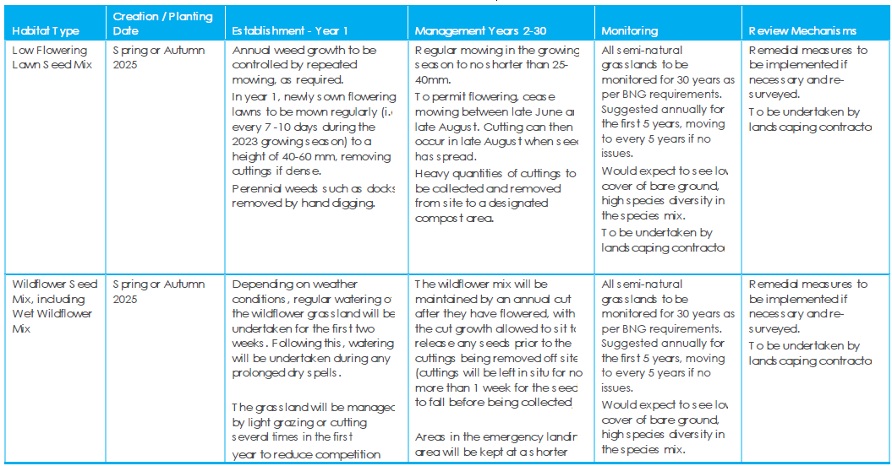
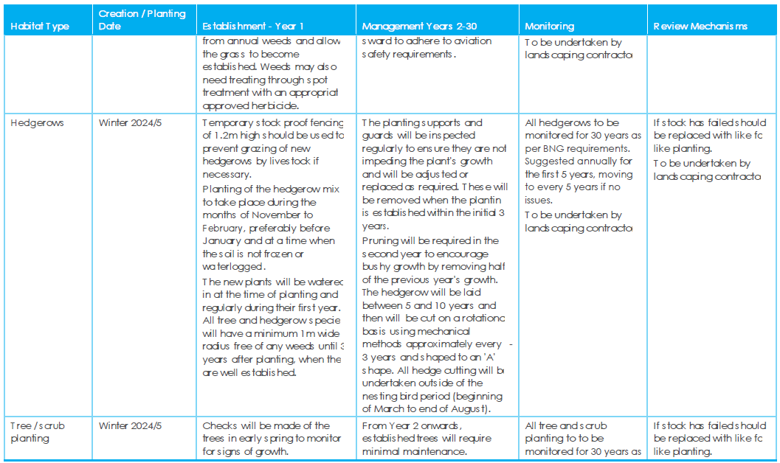
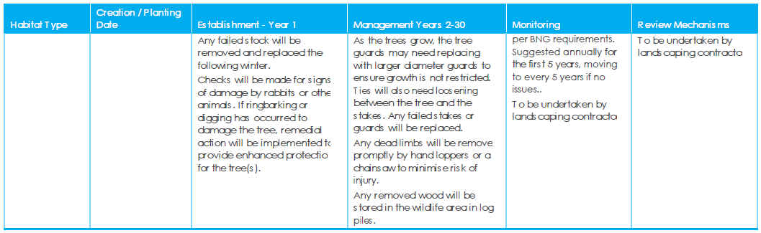

7.3.Conclusions
The biodiversity calculations for the proposed development at the Hessay site have shown an increase in biodiversity net gain of 62.46 % BU, 90.71 % hedgerow units and 29% river units. (BNG calculations found in Ecological Impact Assessment, March 2023).

Appendices

Appendix 1. Planning Notice 23/00626/FULM:
23_00626_FULM-APPROVED-2680202

Appendix 2. Decision Notice:
Decision Notice - Approved 30.10.2025

Appendix 3. Conditions Approval 8a, 10, 13, 15:
Approval-8a_10_13_15-23-00626-FULM

Appendix 4. NMA Proposed site layout:
25_01219_NONMAT-PROPOSED_SITE_LAYOUT-105-046A-241204.pdf

Appendix 5. Revised LEMP and Ecological BNG:
AOD_24_00209-LANDSCAPE___ECOLOGICAL_MANAGEMENT_PLAN-2734611.pdf

REVISED_LANDSCAPE_AND_ECOLOGICAL_MANAGEMENT_PLAN-DRAWING_2642271.pdf

LANDSCAPE___ECOLOGICAL_MANAGEMENT_PLAN-2734611

23_00626_FULM-ECOLOGICAL_IMPACT_ASSESSMENT-2579740

Appendix 6. Flood Risk Assessment:

FLOOD_RISK___DRAINAGE_ASSESSMENT-2579723

Appendix 7. Flood Risk Assessment Addendum:

FLOOD_RISK_ASSESSMENT_ADDENDUM-2656576_Technical Note

Appendix 8. Substation Relocation:

S96a Approval - Substation Relocation

Appendix 9. Approved Substation Elevations:

CUSTOMER_SUBSTATION_ELEVATIONS-2579694.pdf

Appendix 10. Approved Internal Track Design:

Approved_Track-Cross-Section_2644300.pdf

Appendix 11. Site Access Route:

ACCESS_FROM_A1237_HESSAY_FIGURE_4.1-2659977

Appendix 12. Trial Geophysical Survey:

GEOPHYSICAL SURVEY_IMPACT_ASSESSMENT_APPENDIX_E-2579719

Appendix 13. Trial Trenching and Earth Works:

WRITTEN_SCHEME_OF_INVESTIGATION-2715509

24-110_Hessay, York_Trial_Trenching_0.2_

YA_9498_Hessay_Earthwork_Survey_V1

Appendix 14. AIA:

REVISED_ARBORICULTURAL_IMPACT_ASSESSMENT-2642239

Appendix 15. Noise Impact Assessment:

NOISE_IMPACT_ASSESSMENT-2723952

Appendix 16. UXO Assessment:

KD10060010 Detailed UXO Risk Assessment

Appendix 17. Aviation Prevision:

EMERGENCY_AVIATION_PROVISION-2715534.pdf

AOD_24_00209-LANDING_ZONE_1_ZOOMED-2715533

Appendix 18. Glint and Glare Study:

SOLAR_PHOTOVOLTAIC_GLINT-GLARE-STUDY-2644484_Rev_2

Appendix 19. TX / STS Type Test:

TYPE_TEST_REPORT-2715520

NOISE_TEST_REPORT-2715523

Appendix 20. Site Waste Management Plan:

Hessay SWMP

